**Contents**

* What I used/picked
* Amazon Web Services (AWS)
* Amazon EC2
* Boot up an Instance
* Configuring your EC2 Instance

**What I used/picked**

For my project I needed somewhere to host my App continually, along with a CI (Continuous Integration server) I had multiple choices, but for me since I was a student I was eligible for Amazon EC2 which would grant me a year free service.

This would allow me to spin up a micro server for free and keep it running continuously which was what I was looking for. In the case of using one instance for Jenkins and antoher as a deployment server this was perfect. Amazon EC2 is super easy to set up new instances, start/stop them when necessary.

i.e. I could run 2-3 instances as I wished, as long as I either booted them down when not using them, as to not exceed my free tier usage or just run the one continuously.

**Amazon Web Services (AWS)**

“Amazon Web Services (AWS) is a secure [cloud](https://aws.amazon.com/what-is-cloud-computing/) services platform, offering compute power, database storage, content delivery and other functionality to help businesses scale and grow. Explore how millions of [customers](https://aws.amazon.com/solutions/case-studies/) are currently leveraging AWS cloud [products](https://aws.amazon.com/products/) and [solutions](https://aws.amazon.com/solutions/) to build sophisticated applications with increased flexibility, scalability and reliability.”

<https://aws.amazon.com/what-is-aws/>

Amazon Web Services free tier @ <https://aws.amazon.com/free/>

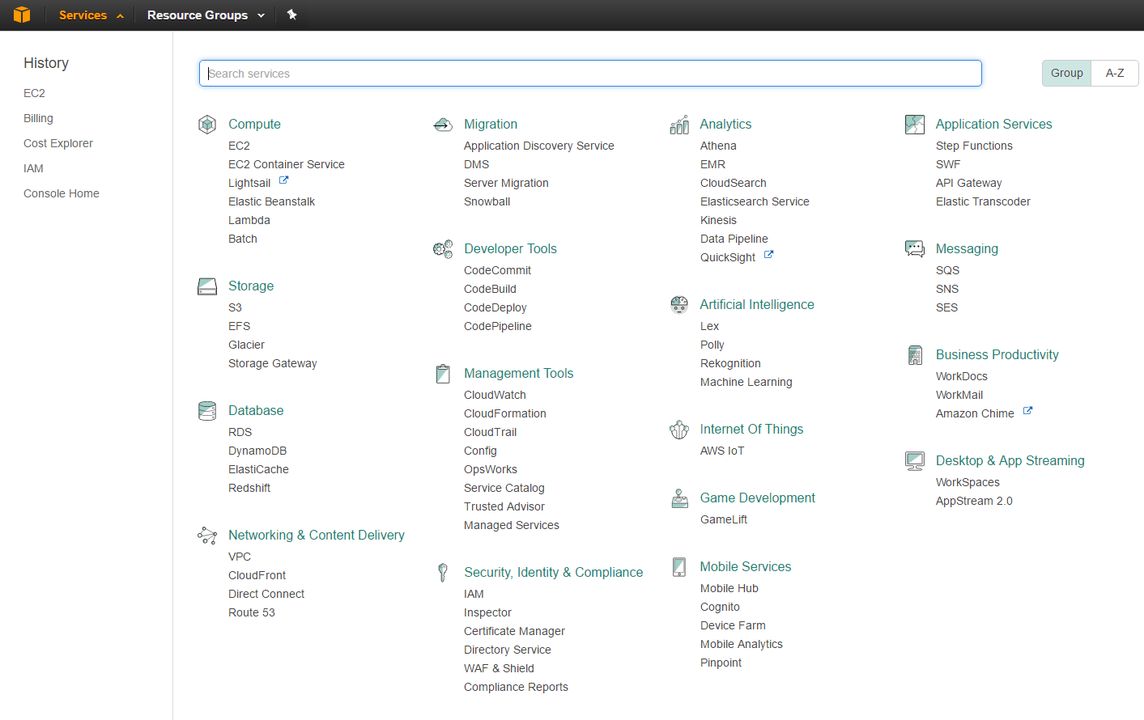

Services available: Taken from My account services drop down

**Amazon EC2**

One of amazon’s series is EC2 Elastic compute cloud (amazon EC2). This allows you to control your resources easily. There is a wide range of machines you can use, this will allow you to easily scale how much capacity you need and when.

More @ <https://aws.amazon.com/ec2/?hp=tile&so-exp=below>

**Boot up an instance**

Sign in and ensure you are in the correct country you wish to create your instances.



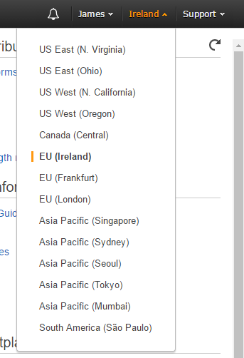

Then click on services on the nav-bar, you will be presented with all the services available, select EC2 under compute.



Creating an instance is easy.

Click on launch instance on the EC2 Dashboard

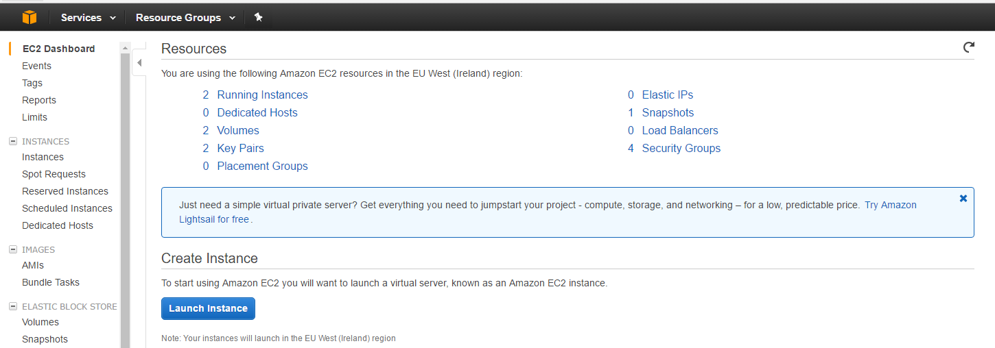

You will be presented with what image you would like installed on the VM, select what you want and follow the steps.

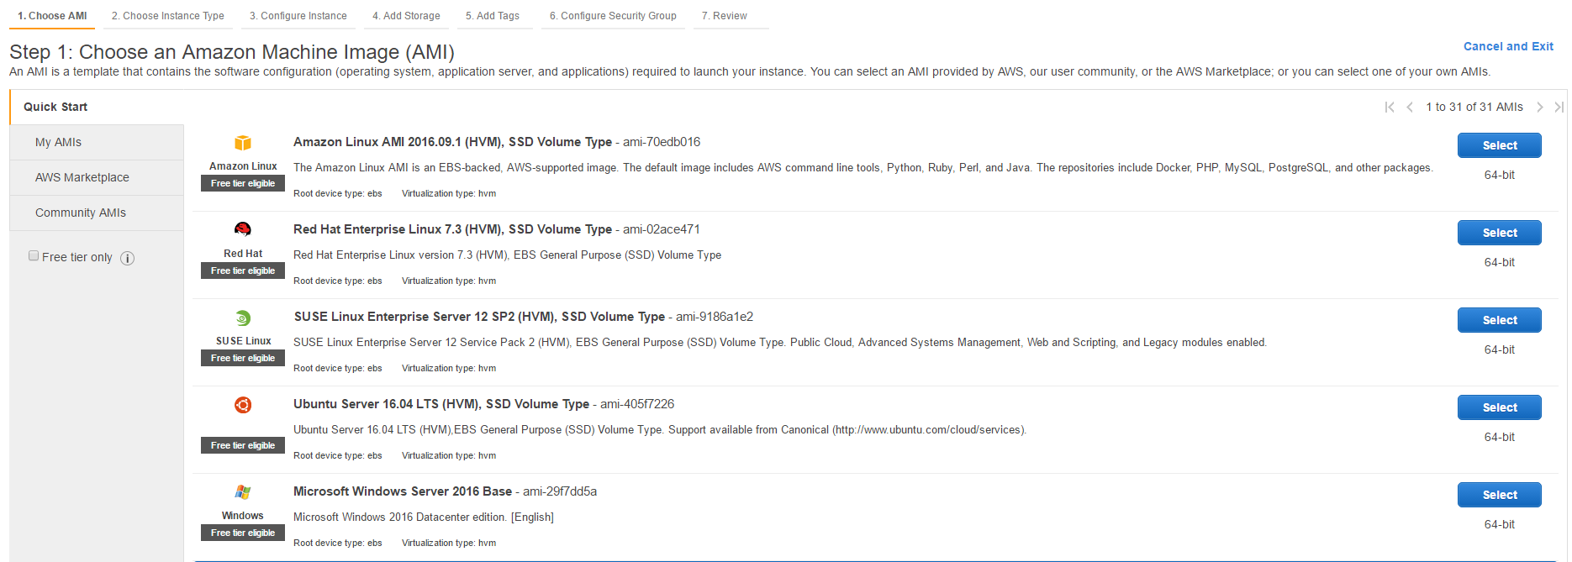

**Configuring your EC2 Instance**

Port Forwarding & opening ports

@ <http://www.lauradhamilton.com/how-to-set-up-a-nodejs-web-server-on-amazon-ec2>

Installing Jenkins on Ubuntu

@ <https://wiki.jenkins-ci.org/display/JENKINS/Installing+Jenkins+on+Ubuntu>

Memory Swap

Running out of memory in Jenkins doing “Npm install” etc?

Make swap file, put what is stored in memory into a file, then read out of later.

@ <https://www.digitalocean.com/community/tutorials/how-to-add-swap-on-ubuntu-14-04>

Continously run your Node server

npm install forever -g

@ <https://github.com/foreverjs/forever>